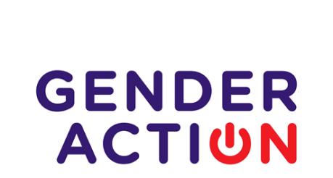

Mutual Learning Workshops

Application Form

Introduction to the Application Form

Task 4.2.2 in GENDERACTION envisages minimising the gap between experienced and less experienced officially appointed national representatives, allowing them to benefit from networking and experience sharing and providing hands‐on coaching based on specific needs. The Task provides opportunities for Mutual Learning Workshops (MLW) which will provide:

- coaching of less experienced national representatives on a one‐to‐one or group basis with more experienced national representatives;
- networking and knowledge sharing visits between national representatives regardless of
experience and know‐how;

Activities include twinning workshops for experienced and less experienced national representatives.
Interested individuals are thus invited to apply for the MLW as described below.

Please make sure that all sections are filled in as requested since incomplete applications will be considered as ineligible.

The deadline is 1 October 2019.
-----------------------------------------------------------------------------------------------------

GDPR Compliance Statement: All data collected using this Form will be processed in accordance with EU GDPR regulations.

Section 1: MLW Details (to be filled by the applicant)

Hosting organisation
Host contact person
Country, City
Dates of MLW

Section 2: Personal Details of Applicant

Name of applicant
Organisation of applicant
Address of organisation
Contact email address of applicant
Contact mobile number of applicant

Section 3: Professional Details of Applicant

Description of Organisation, website link, and mandate (limit 200 words)

Position in organisation and website of applicant (if available)
Years in this position
Responsibilities of applicant as related to GENDERACTION (limit 100 words)
Description of professional experience in gender-related work (limit 100 words)
Knowledge of languages (written/spoken)

Section 4: Motivation of Applicant

Which training area(s) are you most interested in and why? What do you expect to gain from participating in the MLW?
In what ways will the participation in the MLW assist you in your daily work?
(limit 100 words)
e.g.
  - policy design (gender equality plans, objectives, measures, monitoring)
  - implementing National Action Plans
  - evaluation of gender policies
  - monitoring of gender policies
  - increasing female participation in research
  - good practice to integrate gender dimension in R&I programmes

Do you expect that participation in the MLW will assist you to implement or promote any policies, practices or structures in your country? If so, which?
(limit 100 words)

Section 5: Applicant Signature

If selected, I confirm that I will

- Abide by the GENDER ACTION coordinator’s reimbursement rules for participation in this MLW
- Sign a Memorandum of Understanding with the host institution and the GENDERACTION coordinator outlining my responsibilities arising from participation in the MLW
- Endeavour to apply knowledge gained through the MLW in my country
- Report and disseminate as requested by GENDER ACTION on the outcomes of participation in this MLW.

___________________________ __________________

Signature of Applicant Date

___________________________ __________________

Signature of Head of Applicant and Institution Stamp Date

